**Software Requirements**

**Specification**

PHONUM ONLINE

SHOPPING



Supervised by​:

Mr. TEWOGBADE

A project report of the requirements for E-commerce website in Computer Software Engineering Department

EIT (Elerin-mosa Institute of Technology)

(2021 / 2022)

**PART 1**

**Table of Contents**:

1. **Introduction**

**1.1. Purpose**

**1.2. Project Scope**

**1.3. Front-End**

**1.4. Refrence**

**INTRODUCTION**

**1.0 Background**

The goal of this article is to describe the characteristics of the shopping online store. Visitors can view the publicly accessible features here, including product browsing, product details (size, color, and cost), and other static site content. Registered

Users get access to all publicly accessible services and can also buy the

by placing them in your shopping basket. All the contents and Orders can be managed by the admin

a back end (admin side)

This document's goal is to outline the characteristics of the Window Blind E-Commerce.

Website. Visitors can examine the publicly accessible features here, including the ability to explore products, view

details of products (Size, Color, and Price), as well as browse other website static material.

Registered Person can be:

Types of Users of the website are:

Visitors

Customers (Registered Member)

Admin

## 1.1. Purpose

E-commerce service is where users can identify gaps and opportunities, a comprehensive report that includes a project plan with timelines and milestones, a cost analysis, and a schedule.

The aim of this document is to specify complete promote information technology through best service delivery.

**1.2. PROJECT SCOPE**

The objective of this project proposal is to define the project scope of Window Blind E-

Commerce Website and to provide the Estimation.

The advantage would be simple user interface that is easy to understand by all type of the user

**. Design Goals**

The application consists of following main things:

Visitor Features

View Home Banners or Slide Show Gallery

Browse Products

View Product Details

View FAQs

Become a Member through Registration process

View Static Pages

Registered Member Panel

**. Login to site**

Manage Account

My Profile

My Orders

Buy Product (Checkout)

Logout

Admin Panel

Login

**. Dashboard**

Administrator User Management

Site Member (Customer) Management

Shopping Type Management

Product Attribute Management

Product Management

Price Chart Management

Banner Manager

Order Manager

Shipping Management

High level Requirements

System Block Diagram

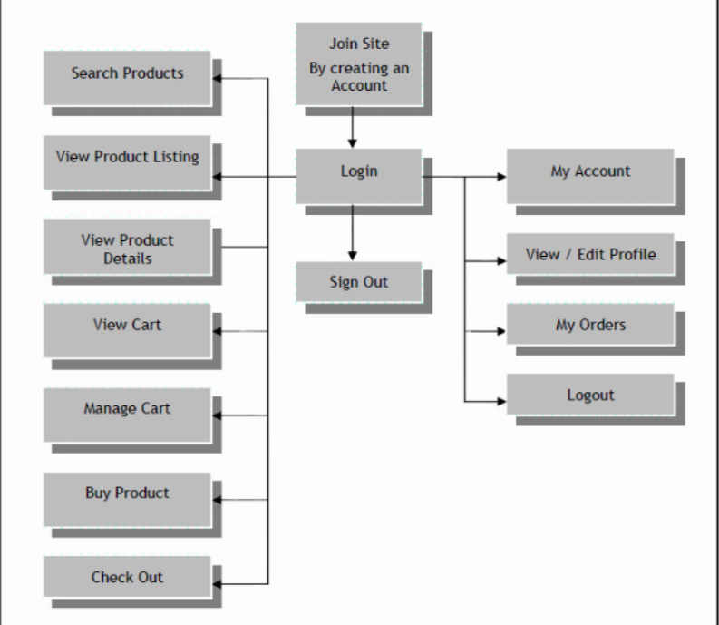

**1.3. Front-End**

**. Home Page**

Views Website Logo, Banners or Slideshow which are integrated with Home Page

View list of Latest Products available with details like

Product Title

Image

View links for Login and Sign Up

Clicking on any link, User will navigate that particular Page

**. Product Display**

Displays products

Click on image will display information of product as well as choice of different product if available

View the details of the products, with Image on Product Detail page

View listing of all Related Products

Product Name

Product size

Image

Clicking on Image, User will navigate to “Product Detail” Page

Product detail Page

Views Product details as follow

Product Title

Preference

Products added to the shopping cart are displayed in View Cart.

Small product images, subtotals, and shipping costs are displayed.

"Update" and "Checkout" links

See the whole shopping cart link

can view the things in its shopping cart (if anything has been purchased, a list of those items will be displayed)

along with the number and overall cost of those purchasing)

Take the item out of the cart.

Recalculate the Sub Total and Update Quantity

User Sign-Up

By entering the login information, they created upon registering in this part, users can access the website.

**To login:**

enter a valid email address and password.

**Link for Forgot Password:**

Password recovery through mail

**Fresh User**:

Available registration link

Registration: Through this feature, new users can open a new account on the website.

Fill out the registration form completely.

**My Orders:**

View all Orders

View order number/ order date/ amount/ quantity

View Status (In Process, Shipped, Open, Rejected)

History/Receipts

View Details of all the orders made

View order id, status, date ordered

Link to re-Order

**Checkout**

Proceed to Shipping Details

View/ Edit Shipping Details

Select Shipping Method

Proceed to Billing Details

View/ Edit Billing Details

Review Order

View Total Order Summary, with Shipping and Billing Details

Proceed to Payment Details

Card payment integration

Order Confirmation

Show confirmation of order with order details on the screen

**Static Pages**

Contact Us

About Us

Privacy Policy

Disclaimer

Terms & Conditions

REFRENCE

A. (2022, May 6). *Scope Proposal Ecommerce Website*. V document. In. https://vdocument.in/scope-proposal-ecommerce-website.html?page=7